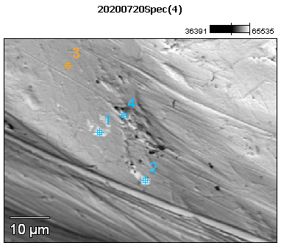

Image Name: 20200720Spec(4)

Image Resolution: 512 by 384

Image Pixel Size: 0.14 µm

Acc. Voltage: 12.0 kV

Magnification: 1800

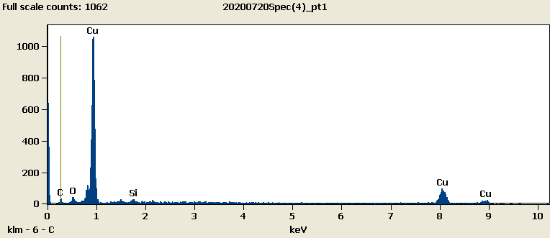

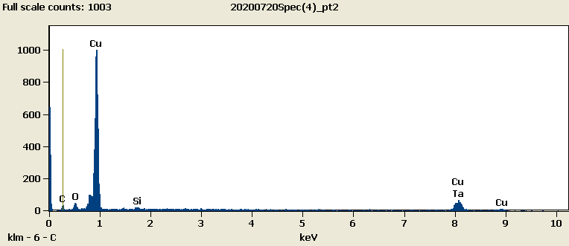

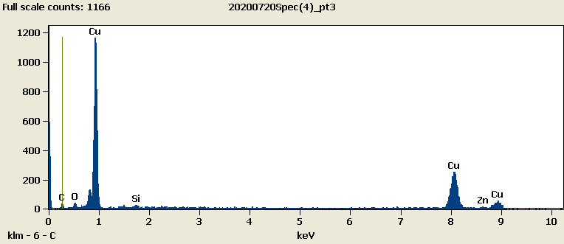

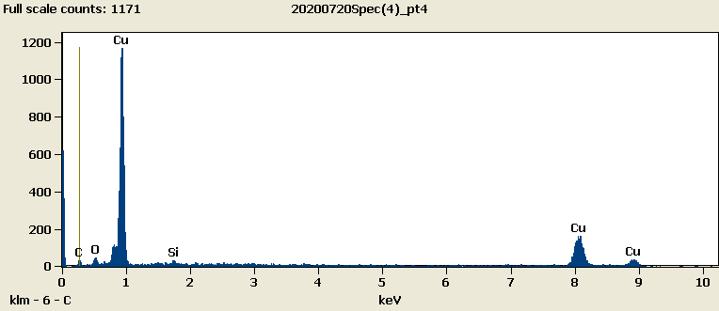

Weight %

|  |  |  |  |  |  |  |
| --- | --- | --- | --- | --- | --- | --- |
|  | ***C-K*** | ***O-K*** | ***Si-K*** | ***Cu-L*** | ***Zn-L*** | ***Ta-M*** |
| ***20200720Spec(4)_pt1*** | 8.29 | 3.43 | 1.53 | 86.75 |  |  |
| ***20200720Spec(4)_pt2*** | 8.22 | 2.99 | 1.28 | 87.51 |  | 0.00 |
| ***20200720Spec(4)_pt3*** | 6.88 | 2.50 | 1.20 | 83.13 | 6.29 |  |
| ***20200720Spec(4)_pt4*** | 7.96 | 3.24 | 1.06 | 87.75 |  |  |

Weight % Error (+/- 1 Sigma)

|  |  |  |  |  |  |  |
| --- | --- | --- | --- | --- | --- | --- |
|  | ***C-K*** | ***O-K*** | ***Si-K*** | ***Cu-L*** | ***Zn-L*** | ***Ta-M*** |
| ***20200720Spec(4)_pt1*** | ±0.56 | ±0.24 | ±0.16 | ±1.07 |  |  |
| ***20200720Spec(4)_pt2*** | ±0.87 | ±0.45 | ±0.17 | ±1.12 |  | ±0.00 |
| ***20200720Spec(4)_pt3*** | ±0.68 | ±0.21 | ±0.16 | ±1.05 | ±1.55 |  |
| ***20200720Spec(4)_pt4*** | ±0.75 | ±0.23 | ±0.17 | ±1.08 |  |  |

# Cations

|  |  |  |  |  |  |  |
| --- | --- | --- | --- | --- | --- | --- |
|  | ***C-K*** | ***O-K*** | ***Si-K*** | ***Cu-L*** | ***Zn-L*** | ***Ta-M*** |
| ***20200720Spec(4)_pt1*** | 0.00 | 0.00 | 0.00 | 0.00 |  |  |
| ***20200720Spec(4)_pt2*** | 0.00 | 0.00 | 0.00 | 0.00 |  | 0.00 |
| ***20200720Spec(4)_pt3*** | 0.00 | 0.00 | 0.00 | 0.00 | 0.00 |  |
| ***20200720Spec(4)_pt4*** | 0.00 | 0.00 | 0.00 | 0.00 |  |  |